# 

**ABOUT US**

We Farhan Woods Company is one of the oldest wooden company in Karachi, Pakistan and has been serving for 22 years. We have been manufacturing wooden items for more than a decade, and have a range of products that suit every need. From wooden doors to windows, door frames (choghats), jas iron frames, panel doors, flush doors etc. we offer them all! Our team is highly experienced and always up to date with the latest techniques.

**WHY CHOOSE US?**

## Excellent dimensional stability

In dry or wet weather there will be hardly any shrinkage or expansion of the door panels. The inner and outer points are not visible; they are made using hydraulic system and special resins.

## Stable to ultraviolet & infrared rays

The stability of door panels and frames was checked by exposing them to direct sunlight, heat and rain for four years. No change in the color or any failure in the material was observed, proving that they are very stable.

## Durability

These doors are immune to any bacterial growth, fungi, and pest and notably to termite attack. They are washable with mild detergents to their original appearance. These characteristics are of lifelong durability.

## Color choice

A variety of colors are available e.g. White, Off-white, Blue, Yellow, Ivory, Pink or any other shade can be produced by our skilled professionals, as per choice of the customer.

## Doorframes (choghats)

We design and fabricate fiberglass doorframes (choghats) of any size with excellent physical properties. We also fix doors with steel-frames, which are already installed during the construction of buildings.

Our technicians fix doors on site at nominal charges.

**Art # 010**

**Art # 011**

# PREMIUM QUALITY COMPOSITE DOORS

Composite materials offer greater strength, durability and insulation. The new composite materials are also environment-friendly and cost-effective.

#### A perfect amalgam of designs, quality and class.

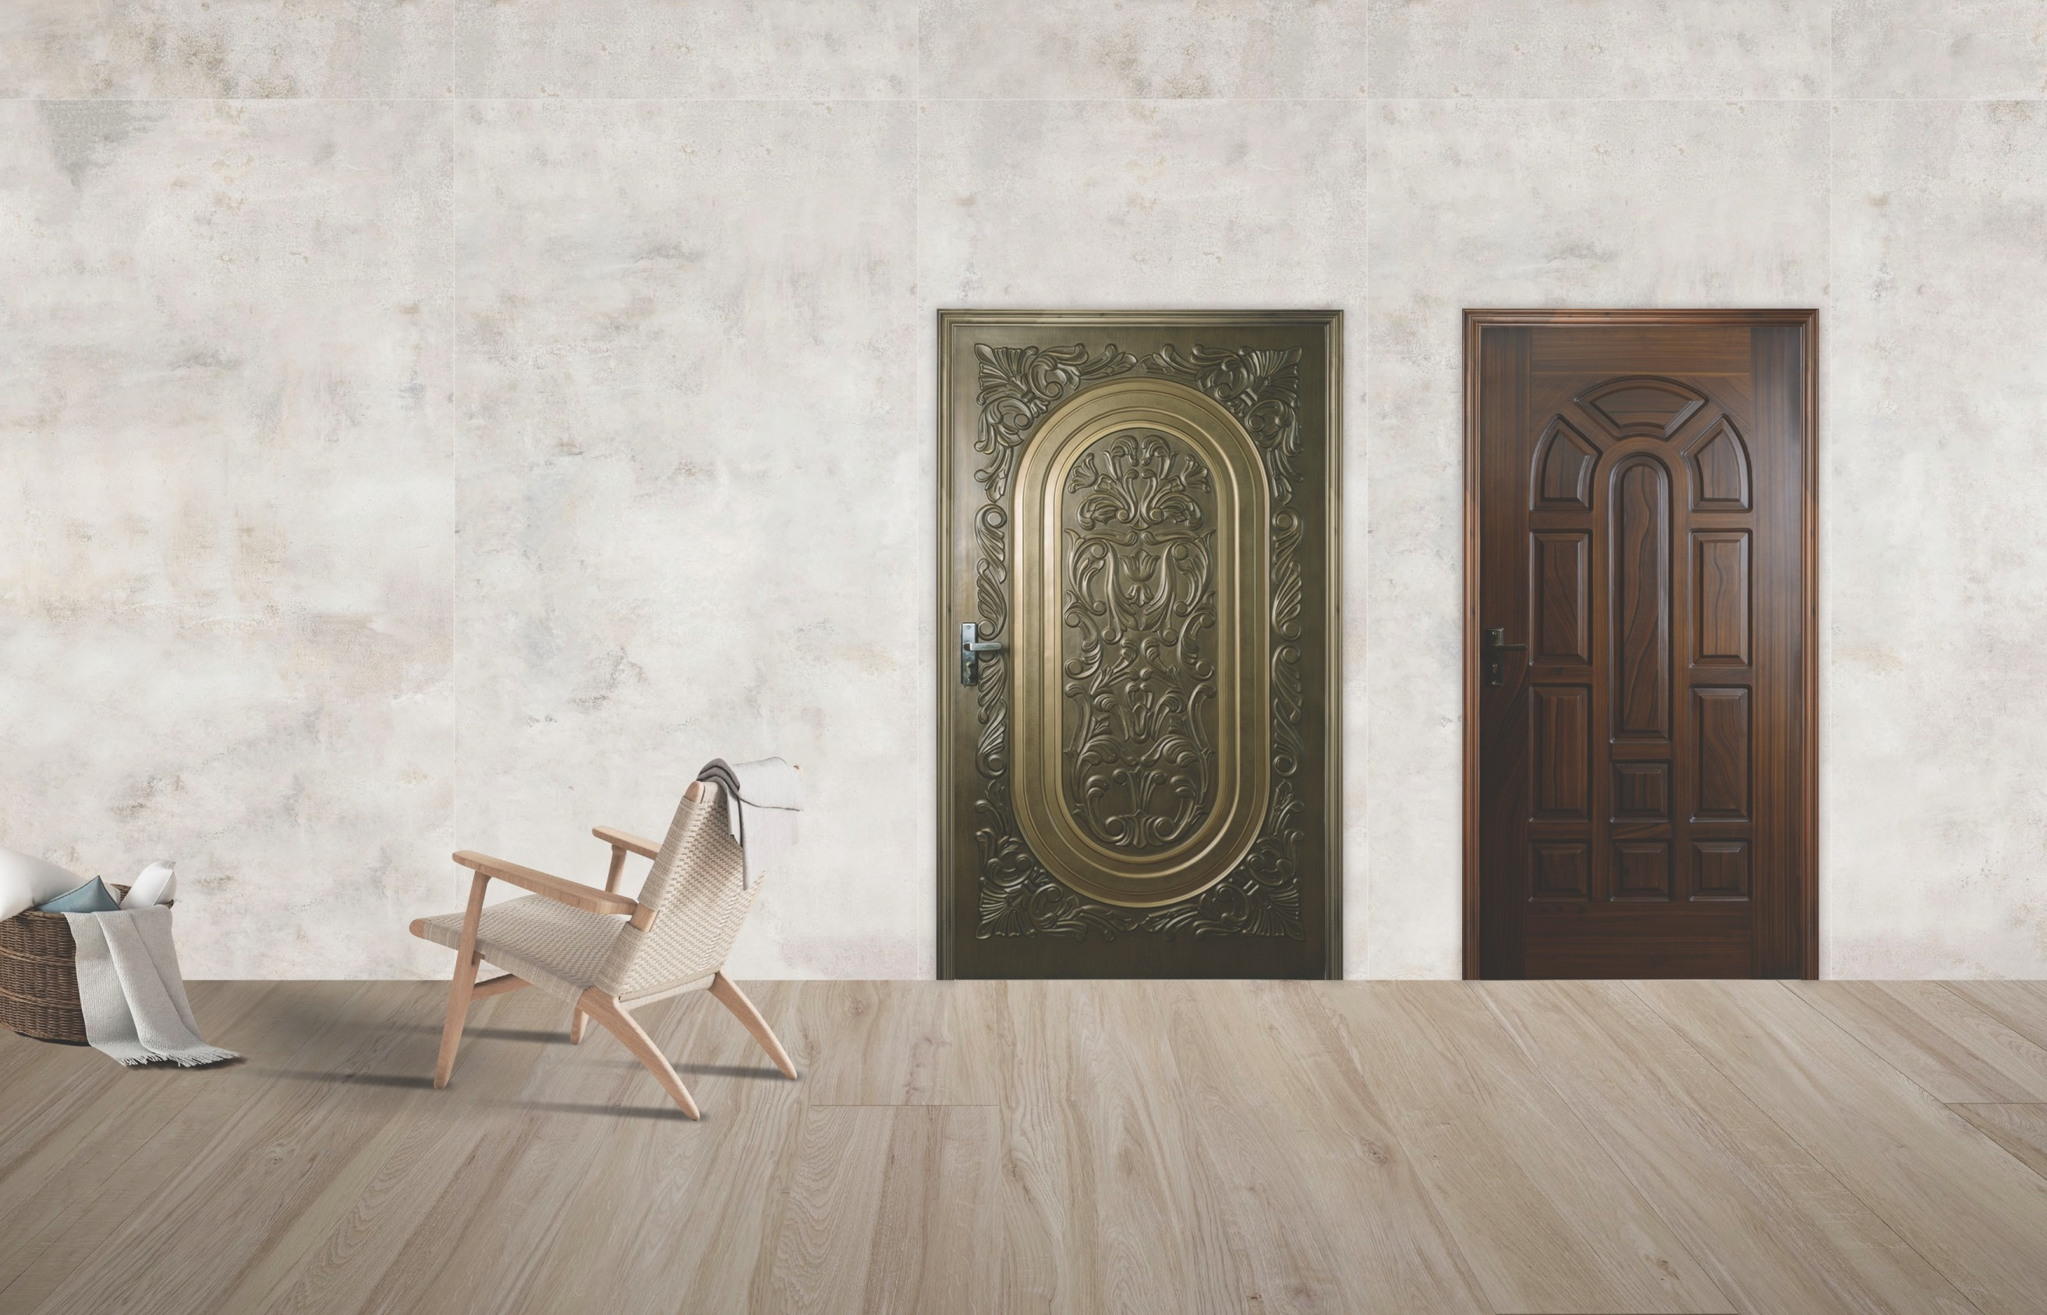

02

Maximum size:

**45” x 87”**

Minimum size:

### 43” x 84”

Maximum size:

### 47” x 84”

Minimum size:

### 24” x 74”

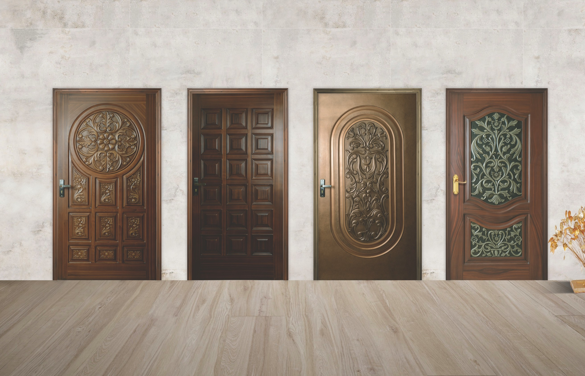

**Art # 012**

**Art # 014**

**Art # 015**

**Art # 020**

|  |  |  |  |
| --- | --- | --- | --- |
| Maximum size: | Maximum size: | Maximum size: | Maximum size: |
| **47” x 96”** | **47” x 95”** | **45” x 87”** | **45” x 87”** |
| Minimum size: | Minimum size: | Minimum size: | Minimum size: |
| **24” x 75”** | **22” x 75”** | **39” x 72”** | **25” x 75”**  03 |

**Art # 025**

**Art # 030**

**Art # 035**

**Art # 040**

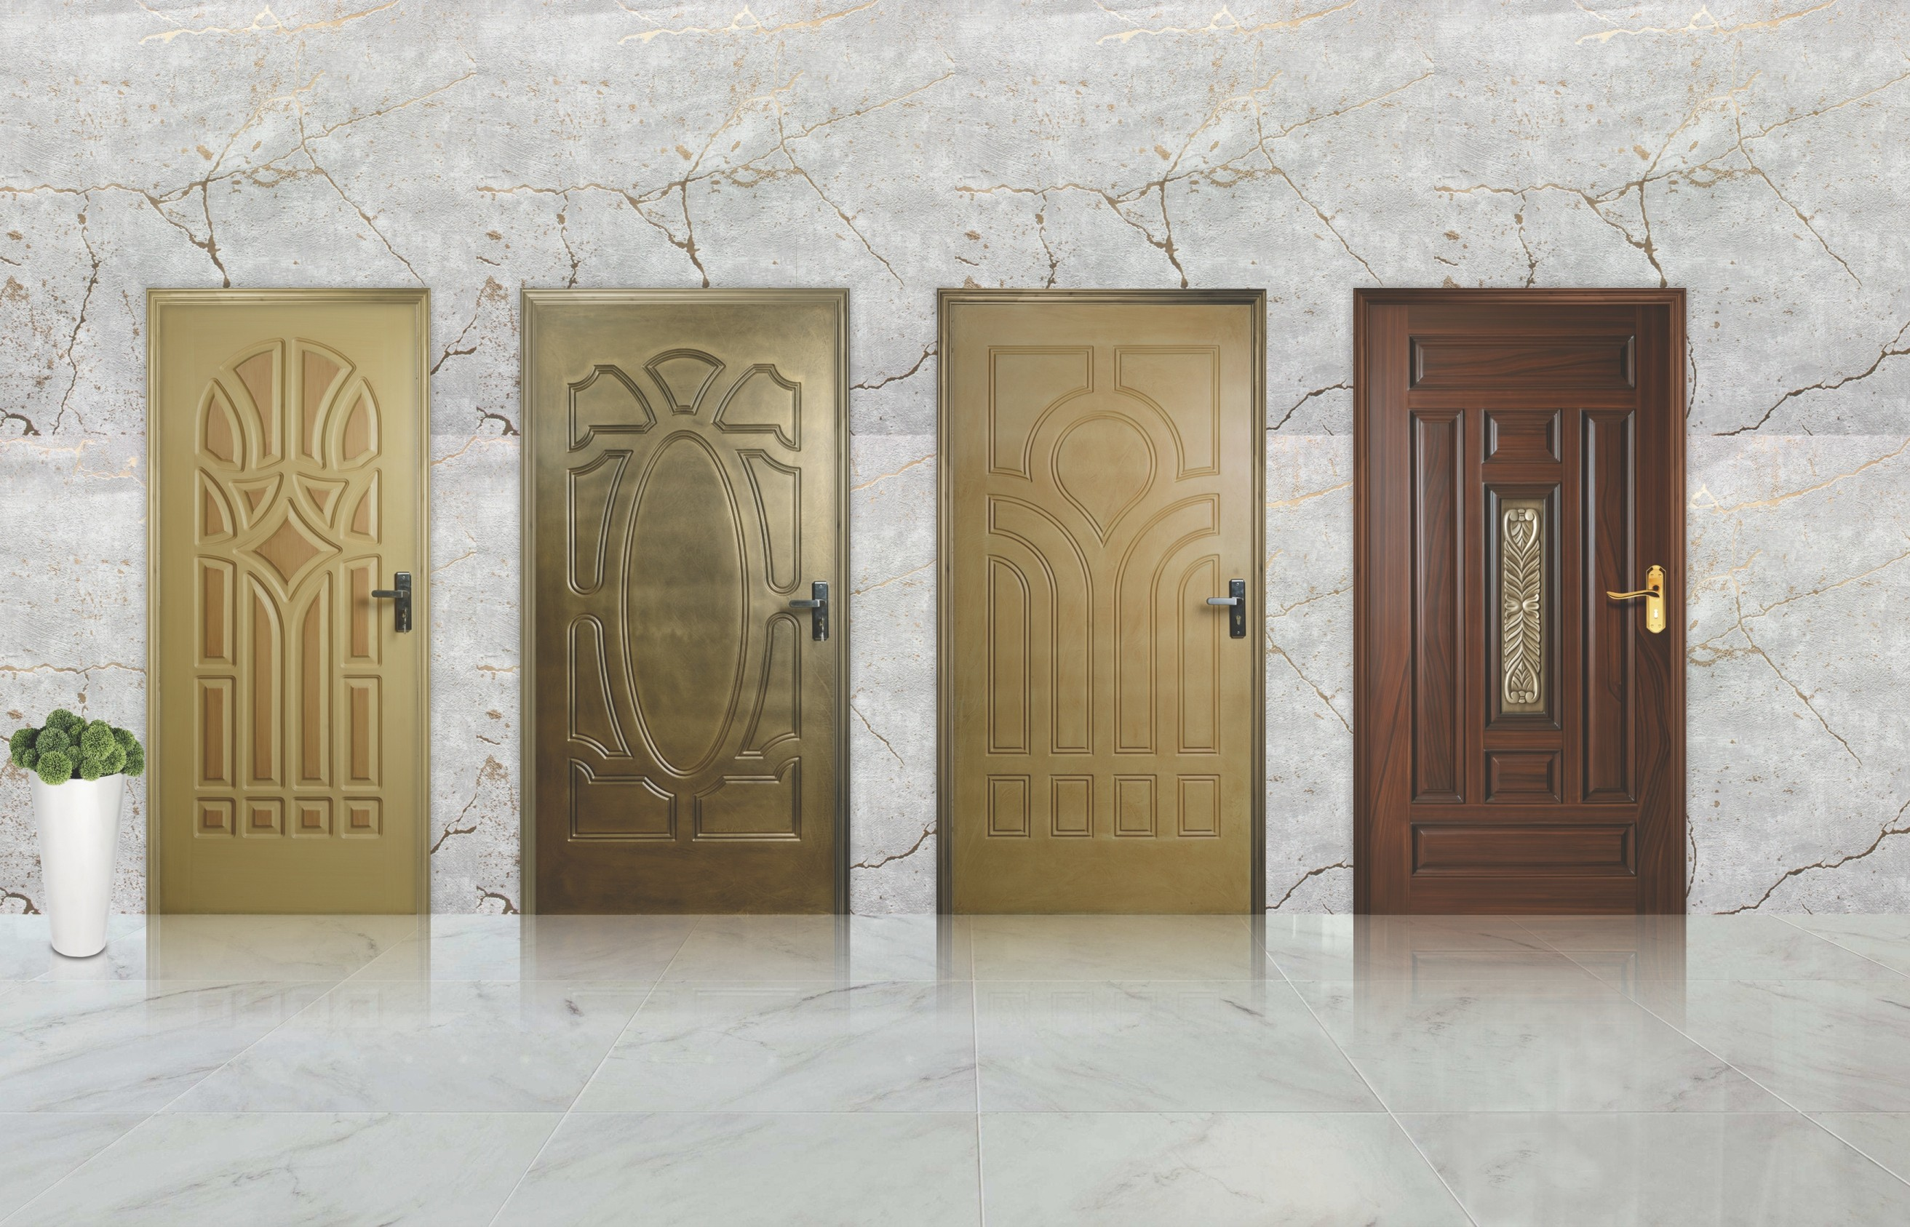Maximum size:

### 45” x 84”

Minimum size:

### 24” x 72”

04

Maximum size:

### 44” x 83”

Minimum size:

### 24” x 75”

Maximum size:

### 44” x 83”

Minimum size:

### 24” x 75”

Maximum size:

### 47” x 96”

Minimum size:

### 25” x 77”

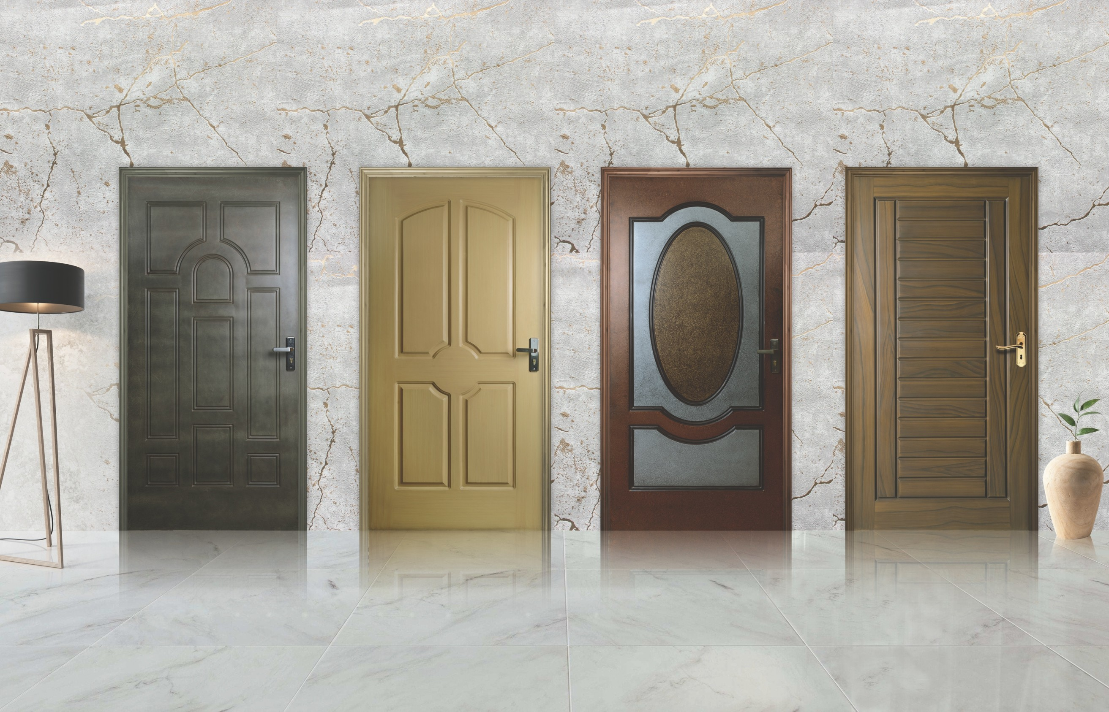

**Art # 045**

**Art # 050**

**Art # 055**

**Art # 060**

|  |  |  |  |
| --- | --- | --- | --- |
| Maximum size: | Maximum size: | Maximum size: | Maximum size: |
| **44” x 83”** | **45” x 84”** | **44” x 83”** | **47” x 96”** |
| Minimum size: | Minimum size: | Minimum size: | Minimum size: |
| **24” x 75”** | **26” x 73”** | **24” x 75”** | **25” x 75”**  05 |

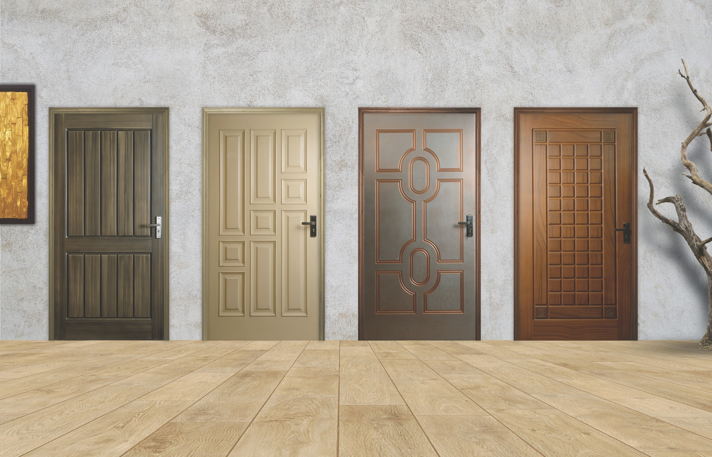

**Art # 065**

**Art # 070**

**Art # 075**

**Art # 080**

|  |  |  |  |
| --- | --- | --- | --- |
| Maximum size: | Maximum size: | Maximum size: | Maximum size: |
| **47” x 90”** | **47” x 84”** | **44” x 83”** | **47” x 90”** |
| Minimum size: | Minimum size: | Minimum size: | Minimum size: |
| **25” x 75”**  06 | **27” x 75”** | **24” x 75”** | **24” x 75”** |



**Art # 085**

**Art # 090**

**Art # 095**

**Art # 100**

|  |  |  |  |
| --- | --- | --- | --- |
| Maximum size: | Maximum size: | Maximum size: | Maximum size: |
| **47” x 90”** | **41” x 82”** | **47” x 96”** | **47” x 84”** |
| Minimum size: | Minimum size: | Minimum size: | Minimum size: |
| **24” x 75”** | **26” x 73”** | **24” x 76”** | **24” x 75”**  07 |

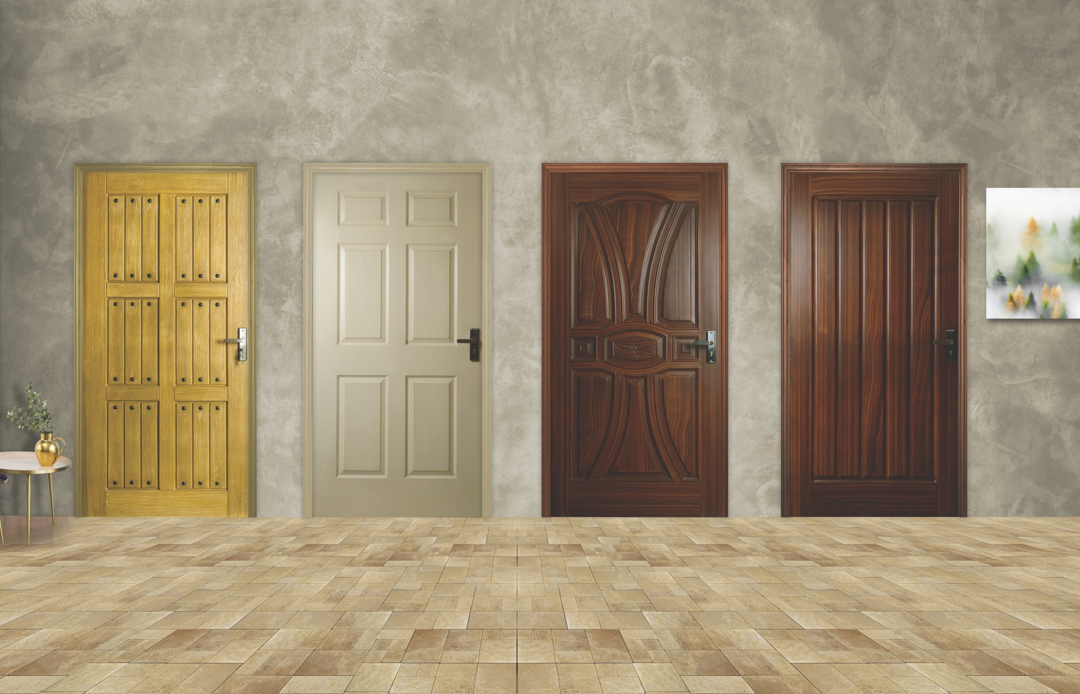

**Art # 105**

**Art # 110**

**Art # 120**

**Art # 125**

|  |  |  |  |
| --- | --- | --- | --- |
| Maximum size: | Maximum size: | Maximum size: | Maximum size: |
| **47” x 95”** | **42” x 82”** | **45” x 84”** | **45” x 84”** |
| Minimum size: | Minimum size: | Minimum size: | Minimum size: |
| **24” x 76”**  08 | **25” x 78”** | **26” x 75”** | **27” x 75”** |

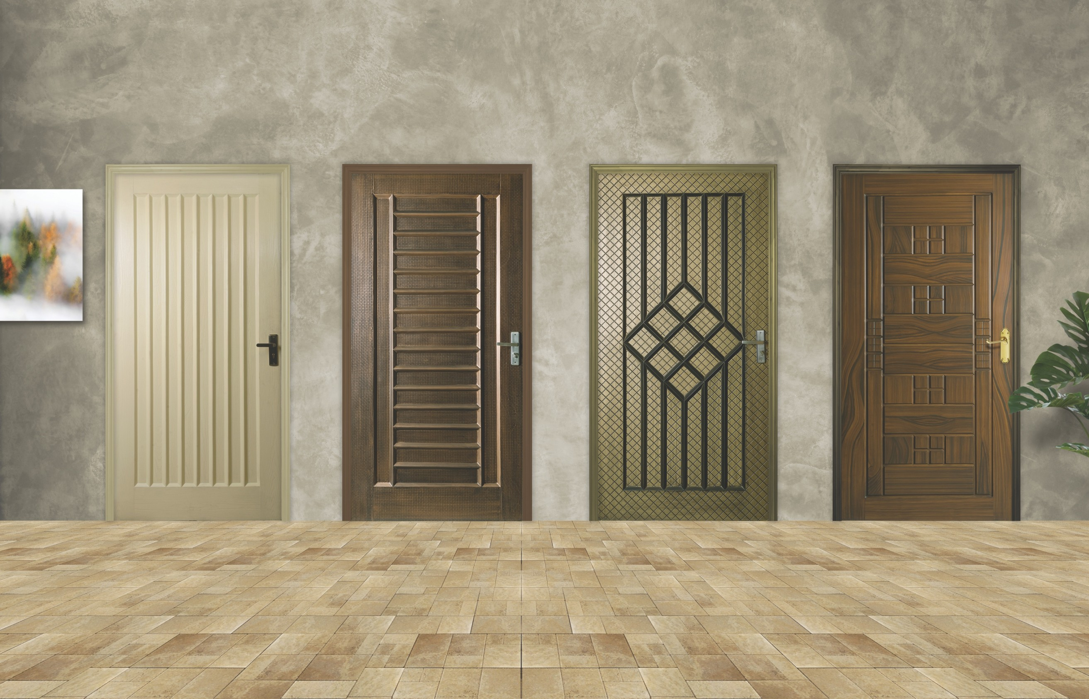

**Art # 130**

**Art # 135**

**Art # 138**

**Art # 142**

|  |  |  |  |
| --- | --- | --- | --- |
| Maximum size: | Maximum size: | Maximum size: | Maximum size: |
| **45” x 84”** | **45” x 84”** | **45” x 87”** | **47” x 87”** |
| Minimum size: | Minimum size: | Minimum size: | Minimum size: |
| **24” x 75”** | **24” x 75”** | **24” x 75”** | **24” x 75”**  09 |

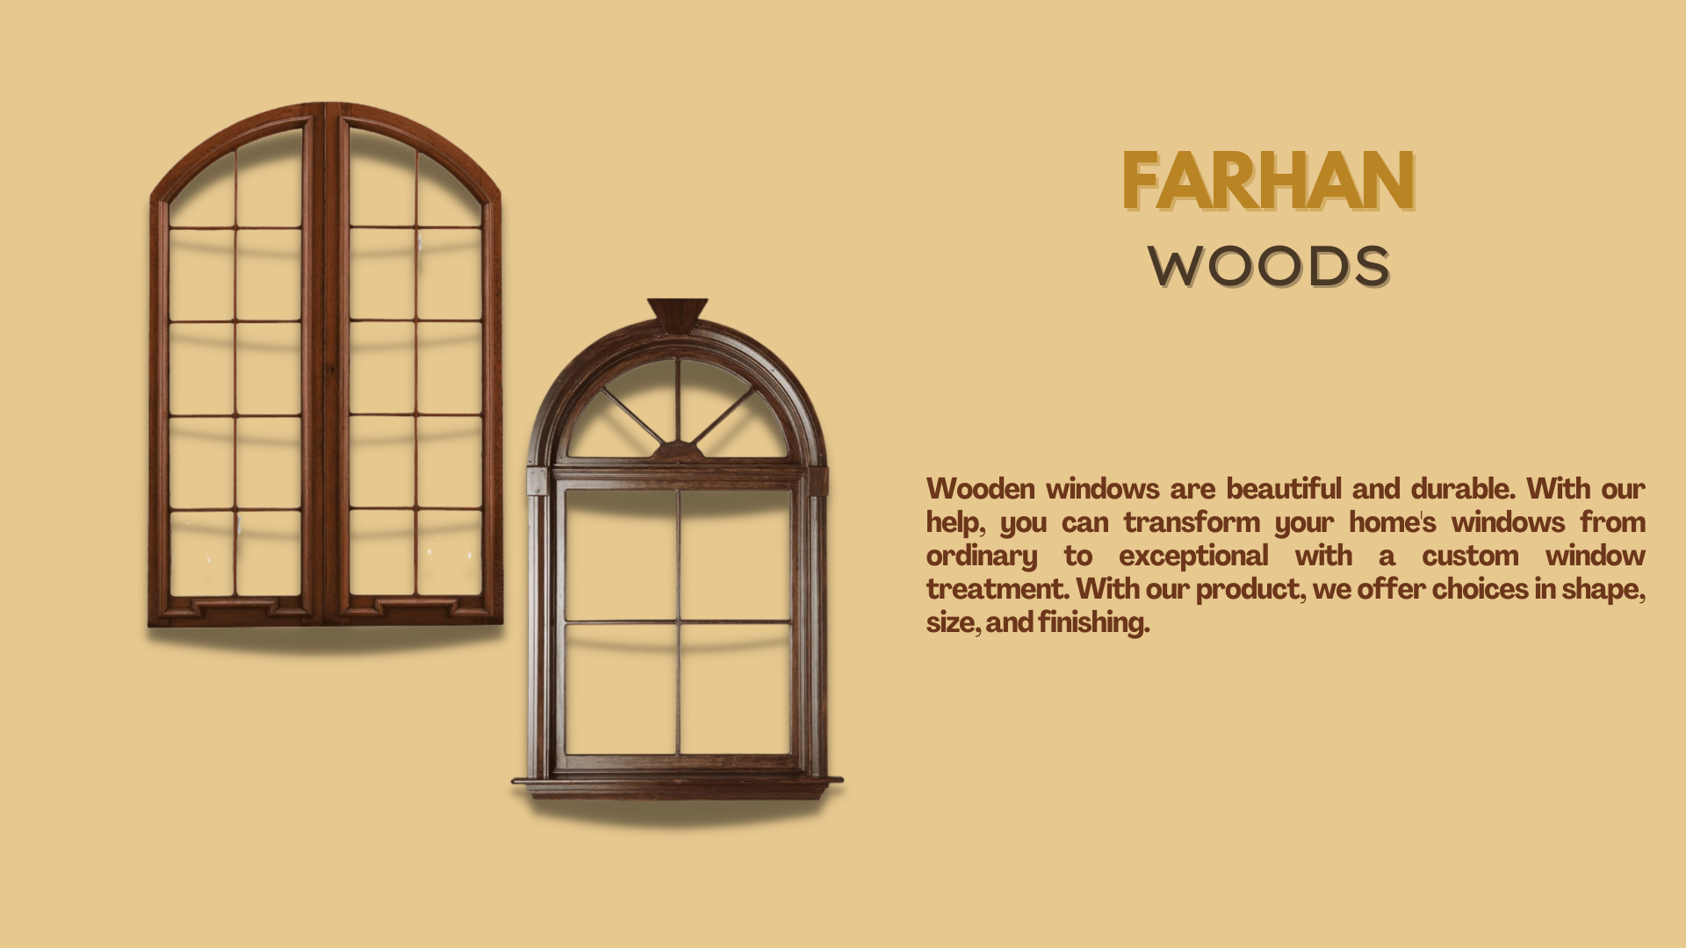

1

|  |  |
| --- | --- |
|  |  |

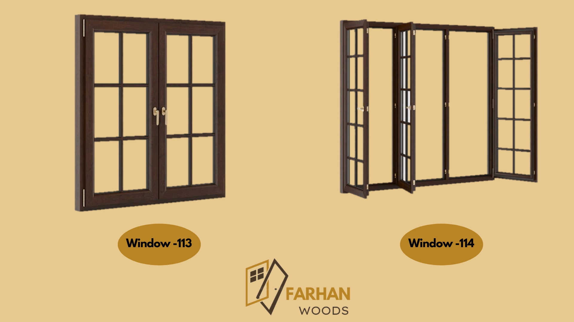

# 

# 

# DOORFRAMES

Doorframes are available in diﬀerent types and sizes. They are anti-corrosion, anti-fungal which make them durable. Water and chemical resistant make them withstand harsh climatic conditions.

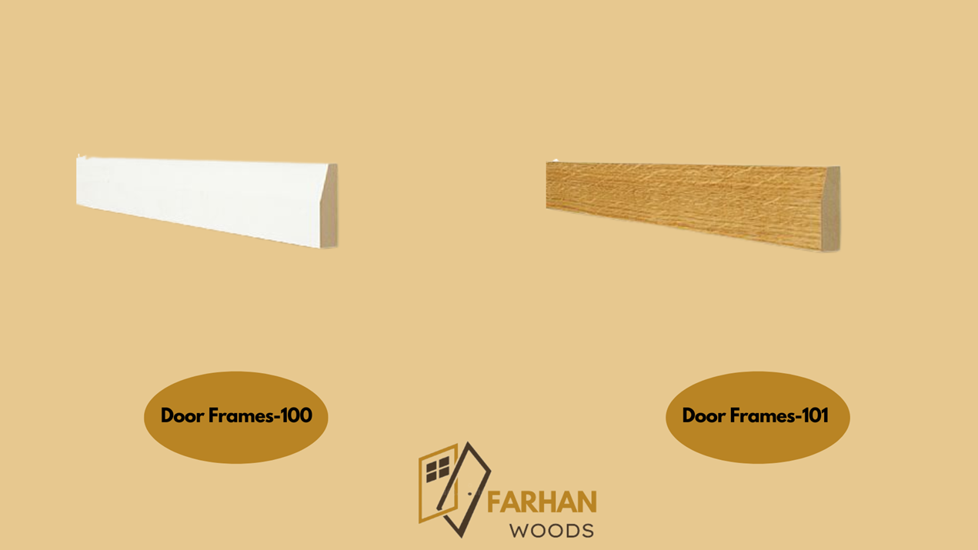

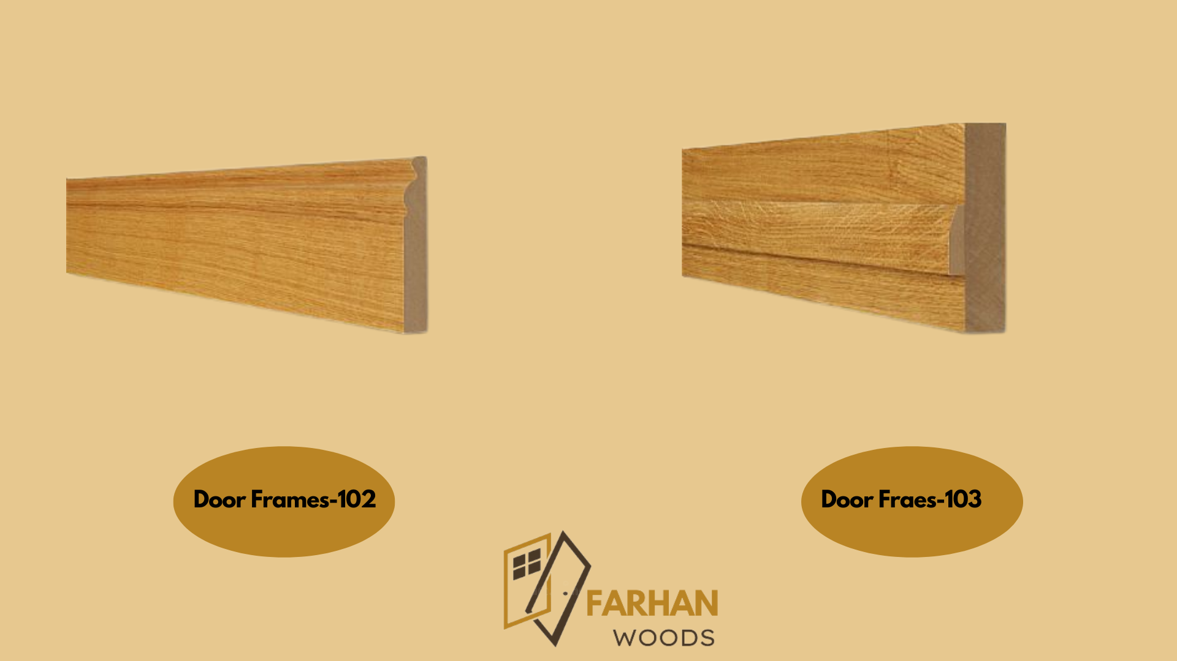

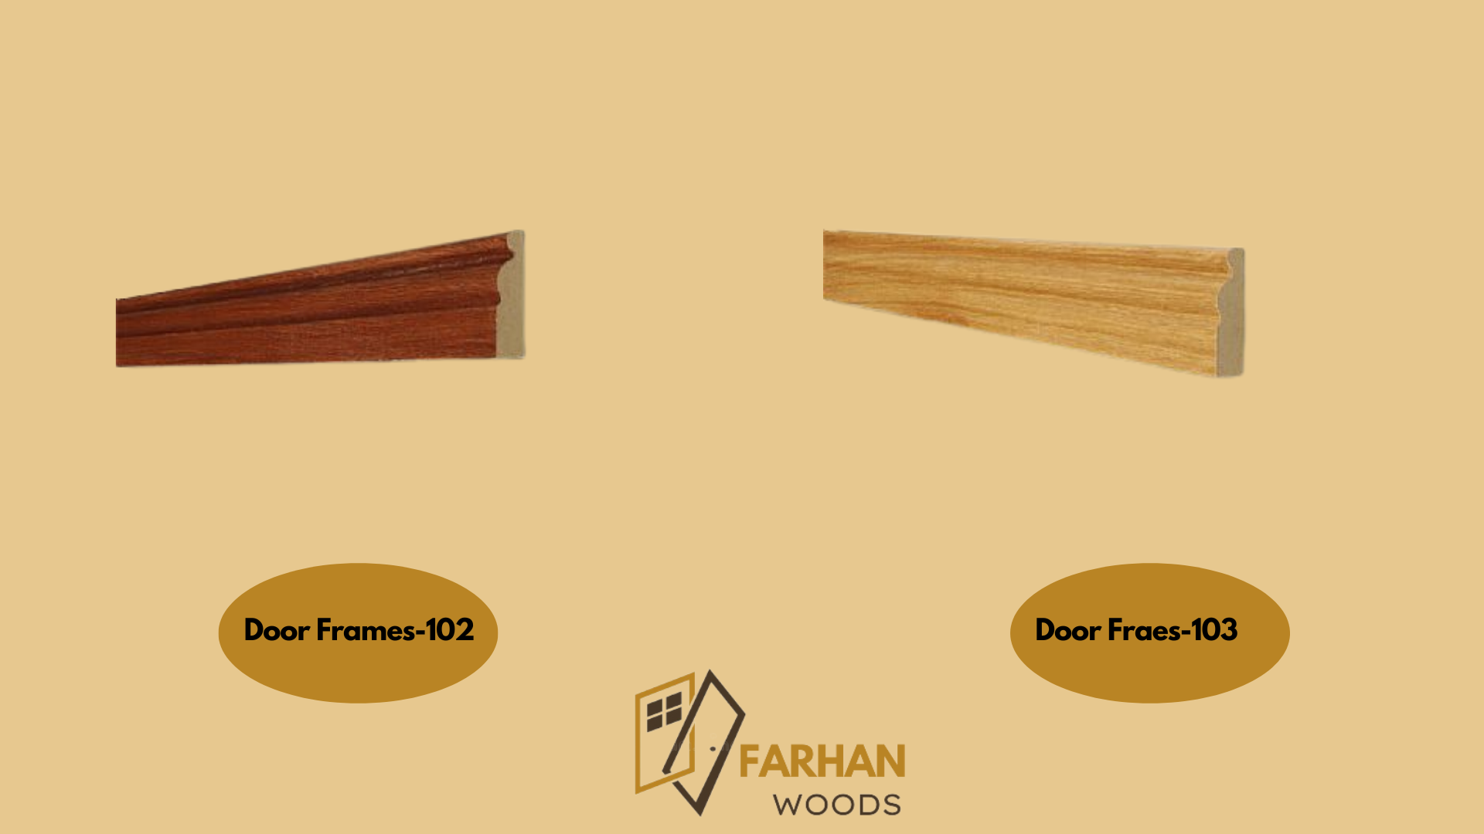

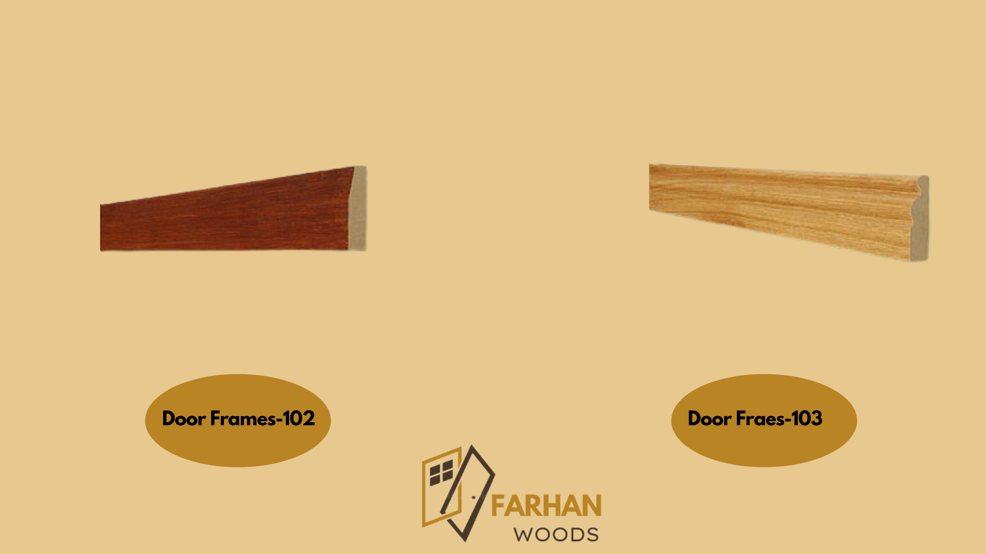

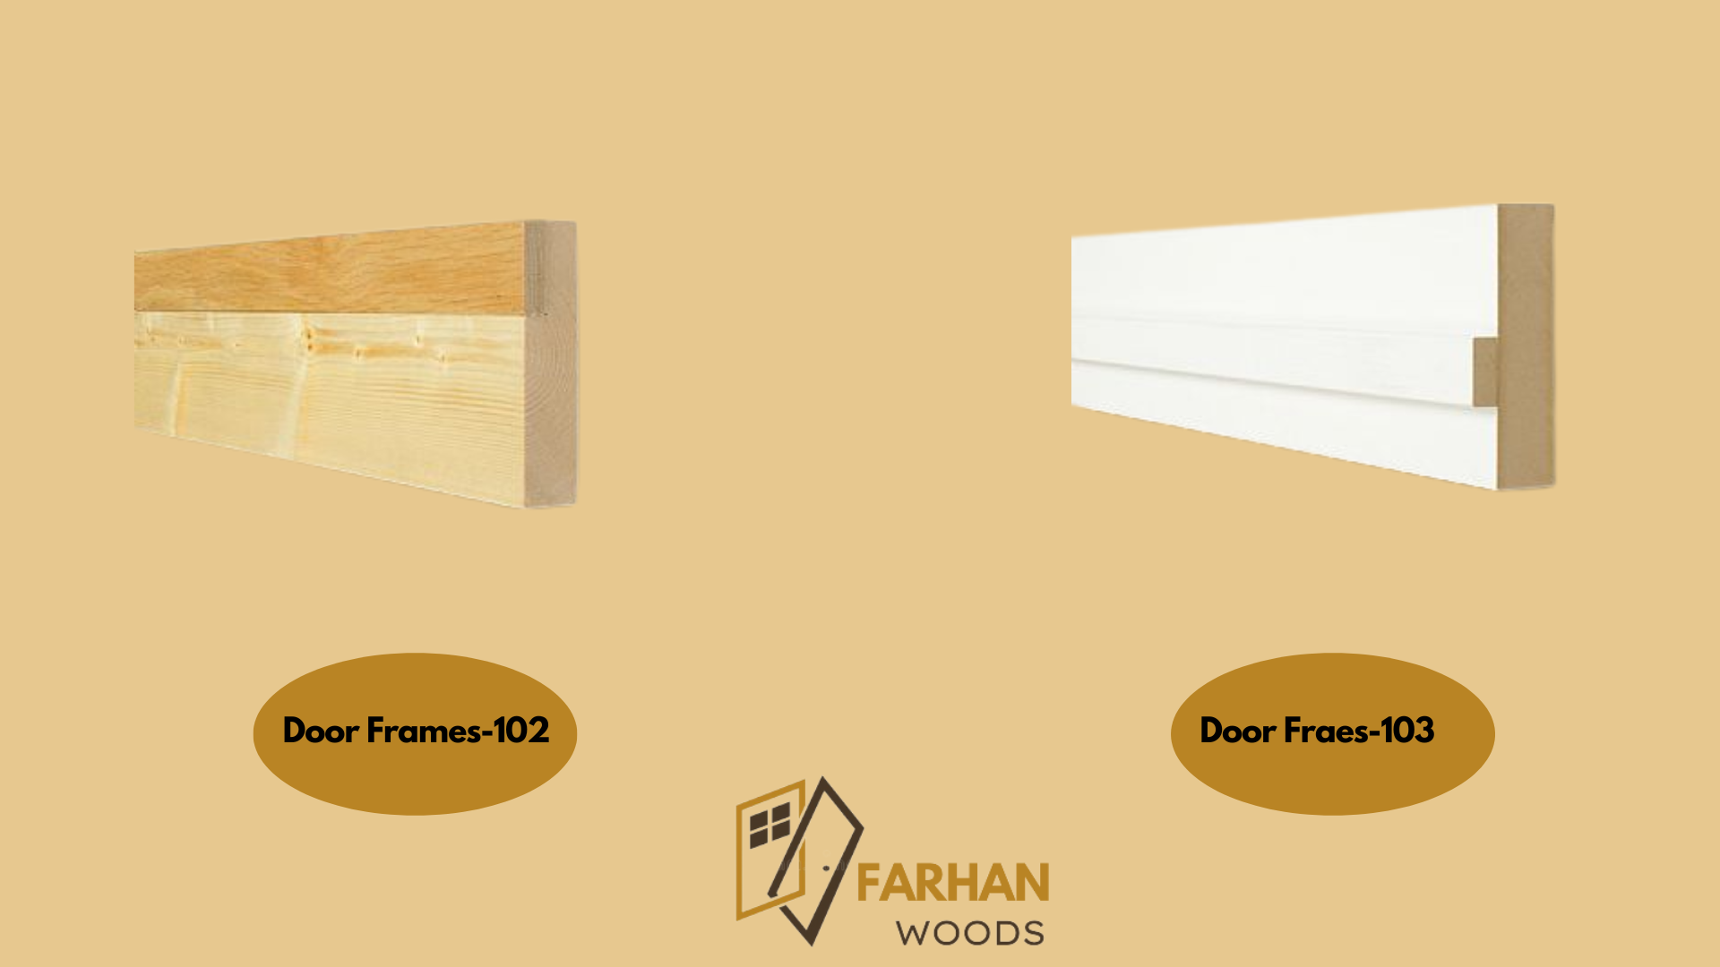

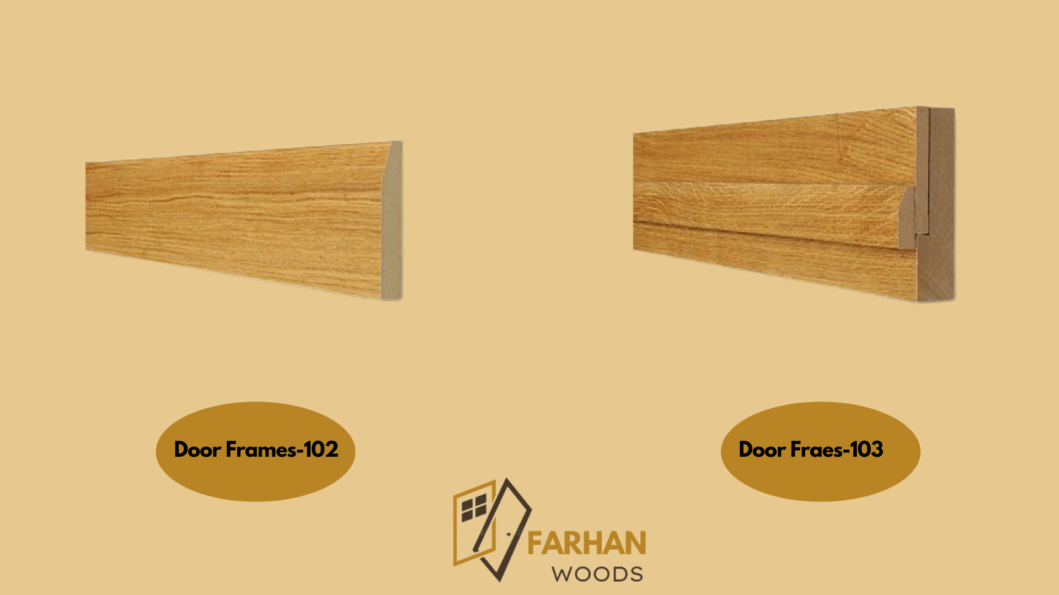

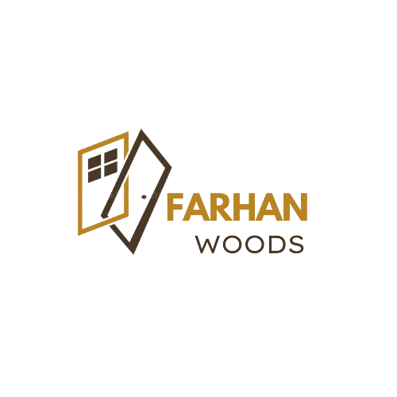

**HEAD OFFICE:**

**Timber market near Spencer eye hospita mcb bank shop no 205 old haji camp karachi, Pakistan**

**Phone: 0335-2538978**

**Email:farhanhashim4600@gamil.com**